IRON INFUSION POLICY UPDATE
07/16/2025

To: Mercy and St. Luke’s Cedar Rapids, Affiliate Sites Radiology Department Managers and MRI Technologists
From: Hannah Monahan MD, MRMD
Date: 07/16/2025

Policy:

Patients should be screened for intravenous iron infusion in the three months preceding an MRI examination due to inherent paramagnetic properties of the medication that may alter T1, T2 and T2* weighted sequences and therefore require specific wait periods prior to MR imaging.

Rationale: Intravenous Iron infusions are often administered to patients with severe iron deficiency anemia who are unable to absorb oral iron (celiac disease, gastric bypass, inflammatory bowel disease), or who lose blood rapidly (GI bleed, menorrhagia). Similarly, iron infusions are commonly used in combination with erythropoiesis-stimulating agents to correct dialysis-associated anemia in patients with end stage renal disease.

It is important to identify the type of intravenous iron patients have or will receive prior to any MRI examination as some forms can significantly alter MR images due to inherent paramagnetic properties. Furthermore, the relatively long half-lives of several infusions may result in further imaging delay. The table below contains information regarding several forms of intravenous iron currently available, if they have effects on MR imaging and recommended wait times between administration and MR examination:
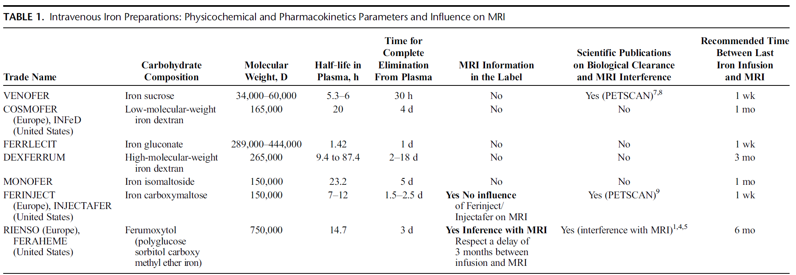

Given the above information, the following wait periods are recommended after intravenous iron administration:

- Routine outpatients: Technologists should reference the above table when scheduling patients for routine, outpatient MRI, noting that a 3-month delay is required after Feraheme (Ferumoxytol) administration.
- Expedited inpatients: Recommend a 3 day wait period after administration given the T1 shortening effects and resultant intravascular enhancement that may significantly limit accurate exam interpretation.
- Emergent patients: No wait time required, although the ordering provider should be made aware that there could be significant limitations in exam interpretation.

Sources:
Perry T, editor. Therapeutics Letter. Vancouver (BC): Therapeutics Initiative; 1994-. Letter 97, Intravenous (IV) iron for severe iron deficiency. 2015 Dec.
McCullough, B.J., Kolokythas, O., Maki, J.H. and Green, D.E. (2013), Ferumoxytol in clinical practice: Implications for MRI. J. Magn. Reson. Imaging, 37: 1476-1479. https://doi.org/10.1002/jmri.23879
Rostoker G, Cohen Y. Magnetic resonance imaging repercussions of intravenous iron products used for iron-deficiency anemia and dialysis-associated anemia. J Comput Assist Tomogr. 2014 Nov-Dec;38(6):843-4. doi: 10.1097/RCT.0000000000000146. PMID: 25229202.

